BUILD AN EVENT MANAGEMENT SYSTEM USING SALESFORCE

**TEAM ID: NM2023TMID07941**

# INTRODUCTION

* 1. Overview

Create Custom Objects: Salesforce allows you to create custom objects, which are like database tables, to store event-related data. You can create custom objects such as "Events," "Registrations," "Attendees," and "Speakers" to store information about the events you're managing.

Define Relationships: You can define relationships between the custom objects you created to establish connections between the different data entities. For example, you can create a lookup relationship between "Events" and "Registrations" to associate registrations with specific events.

Customize Fields: You can customize the fields within the custom objects to capture relevant event data. For example, you can create fields such as "Event Name," "Event Date," "Registration Status," "Attendee Name," and "Speaker Bio" to capture important event details.

Build Workflows: Salesforce allows you to build workflows, which are automated processes, to streamline event management tasks. For example, you can create workflows to automatically send confirmation emails to registrants, update registration status based on payment status, or trigger follow-up tasks after the event.

Create Reports and Dashboards: Salesforce provides robust reporting and dashboard capabilities that allow you to generate insights and track event performance. You can create reports and dashboards to monitor event registrations, attendance, revenue, and other key metrics to assess the success of your events.

Leverage Salesforce AppExchange: Salesforce's AppExchange is a marketplace that offers a wide range of pre-built applications and integrations. You can leverage these apps to enhance your event management system, such as integrating with third-party event registration tools, email marketing platforms, or event planning apps.

Enable Community Portals: Salesforce Community Cloud allows you to create self-service portals for event attendees, sponsors, or speakers. You can create custom community portals that provide access to event information, allow attendees to register and pay for events, enable sponsors to view sponsorship opportunities, and allow speakers to submit session proposals.

Automate Event Marketing: Salesforce's Marketing Cloud can be integrated with your event management system to automate event marketing campaigns. You can use features such as email marketing, social media marketing, and marketing automation to promote your events, drive registrations, and engage with attendees.

Enable Mobile Access: Salesforce offers a mobile app that allows you and your team to access event data and manage events on the go. You can use the Salesforce mobile app to view event details, update event data, and communicate with team members or attendees in real-time.

Ensure Data Security: Salesforce provides robust data security features, such as user authentication, role-based permissions, and data encryption, to protect your event data. You can configure these security settings to ensure that your event data is protected from unauthorized access.

Building an event management system using Salesforce involves customizing the platform to meet your specific event management needs. You can create custom objects, define relationships, customize fields, build workflows, create reports and dashboards, leverage AppExchange apps, enable community portals, automate event marketing, enable mobile access, and ensure data security to create a comprehensive event management system within Salesforce.

1. Top of Form

1.2 Purpose

* 1. Top of Form

Define the Event Object: In Salesforce, you can create custom objects to represent different data entities. Create a custom object called "Event" with fields such as event name, event date, event location, event description, registration status, and any other relevant fields for your event management system.

Create Event Registration Process: Use Salesforce's automation tools, such as Process Builder or Flow, to create an event registration process. This process can include creating a new event registration record when a new lead or contact expresses interest in attending an event, updating the registration status based on registration status changes, and sending confirmation emails to registrants.

Design Event Landing Page: Create a custom object tab or a visualforce page to serve as the event landing page. This page can display information about upcoming events, allow users to register for events, and provide a way for users to view their event registration status.

Implement Event Payment and Ticketing: If your event requires payment for registration, you can use Salesforce's integration with a payment gateway, such as PayPal or Stripe, to process payments. You can also create custom fields on the Event object to track ticket information, such as ticket type, ticket price, and ticket quantity.

Manage Event Attendees: Use Salesforce's native CRM features, such as leads and contacts, to manage event attendees

# Problem Definiton & Design Thinking

* 1. Empathy Map

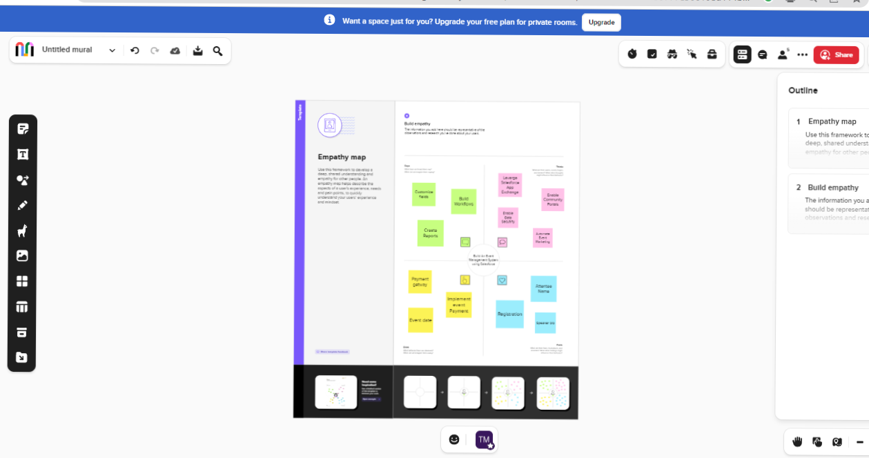

* 1. IDEATION & BRAINSTROMING MAP

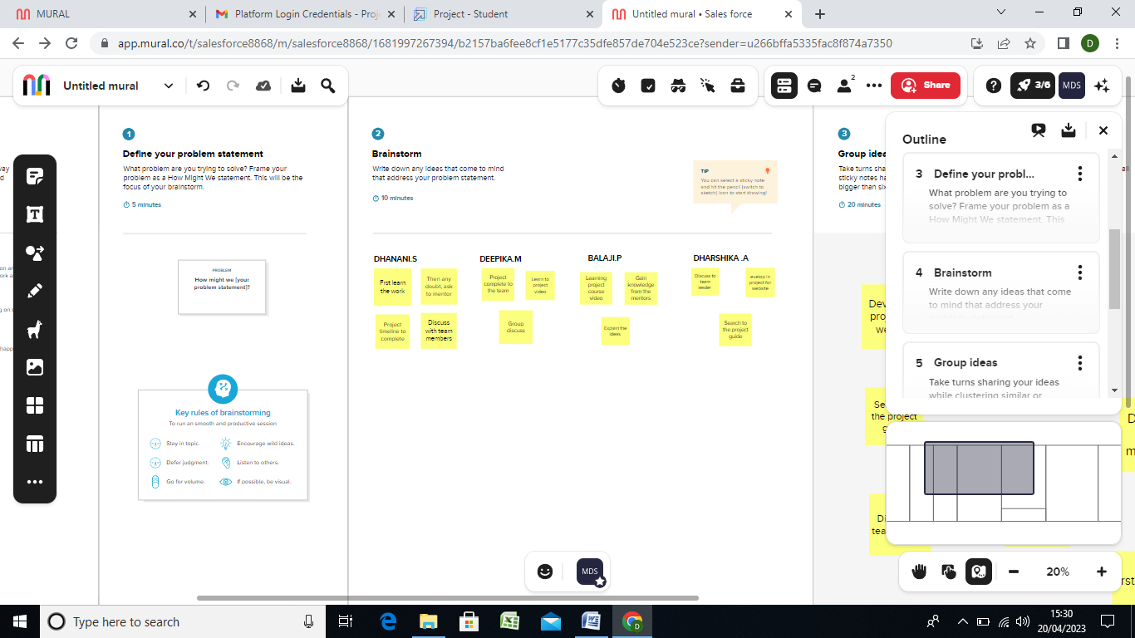

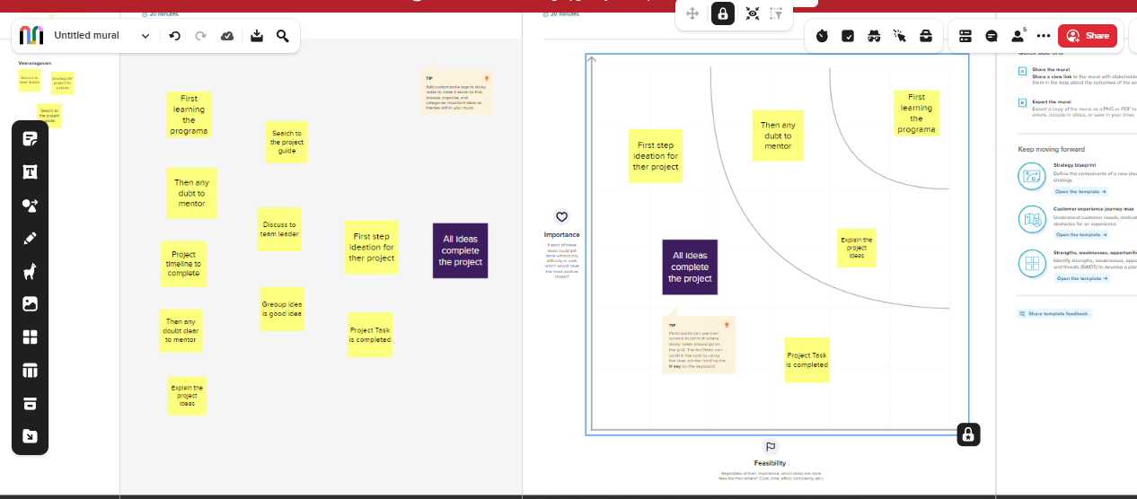

# RESULT

3.1 DATA MODELL:

|  |  |
| --- | --- |
| Object name | Fields in the object |
| Obj-1  1.Attendee | |  |  | | --- | --- | | Field label | Data type | | Attendee name | Phone | |
| Obj-2  2.Speaker | |  |  | | --- | --- | | Field label | Data type | | Speaker name | Email | |
| Obj-3  3. Vendors | |  |  | | --- | --- | | Field label | Data type | | Vendor name | Phone | |

3.2 ACTIVITY AND SCREENSHOT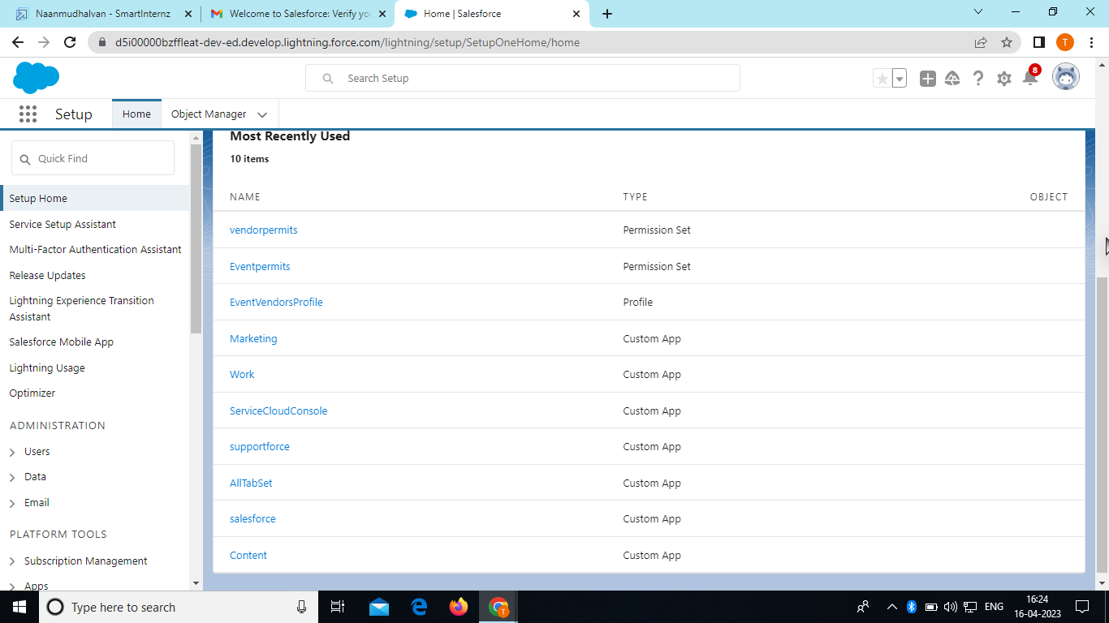

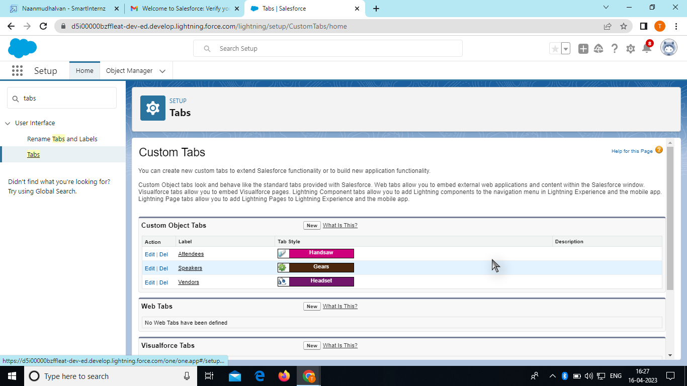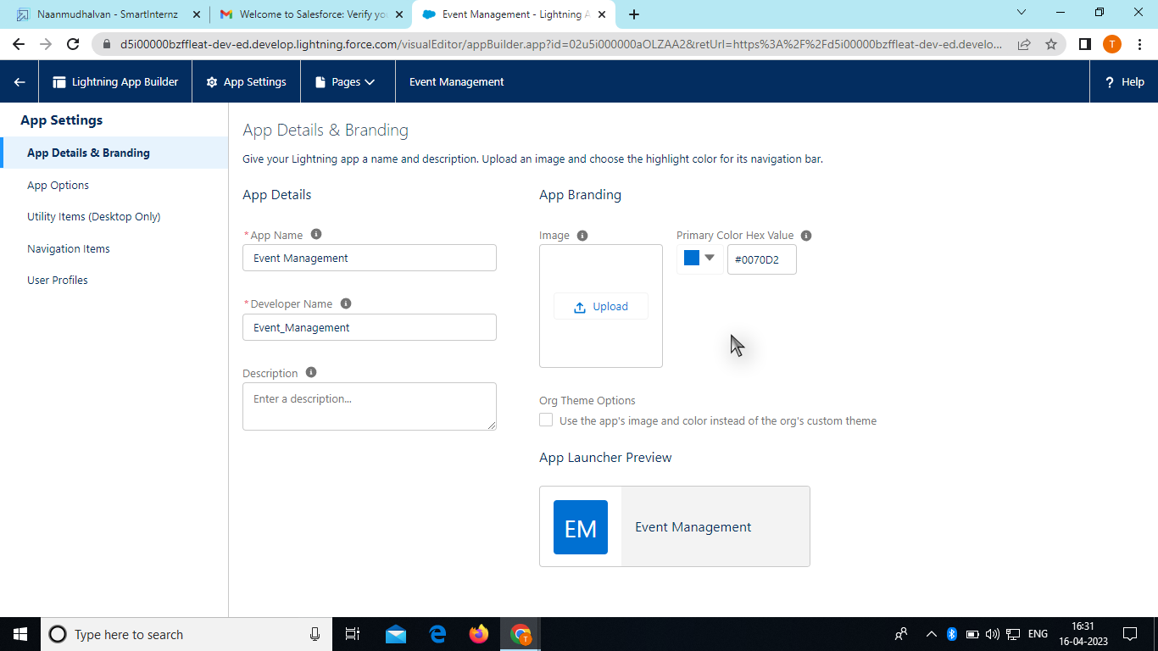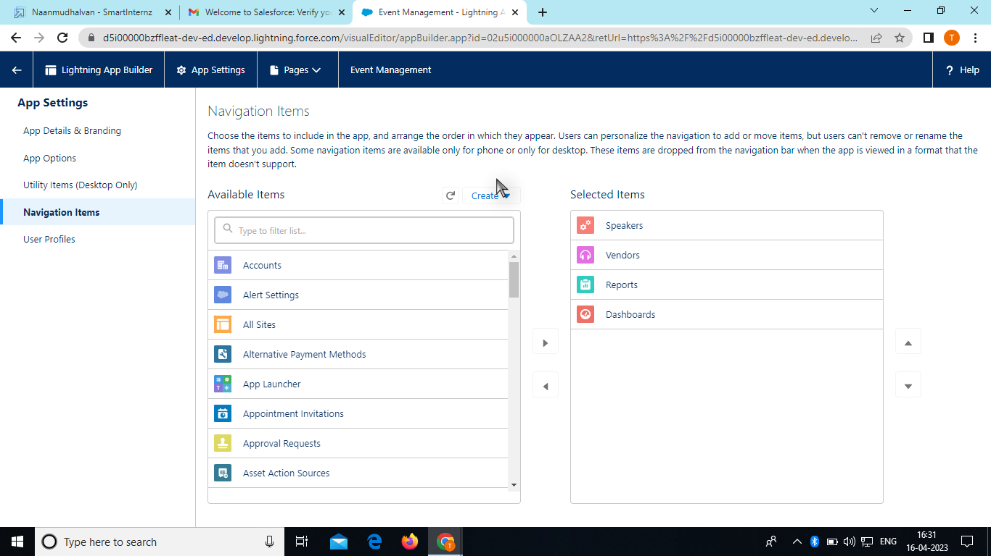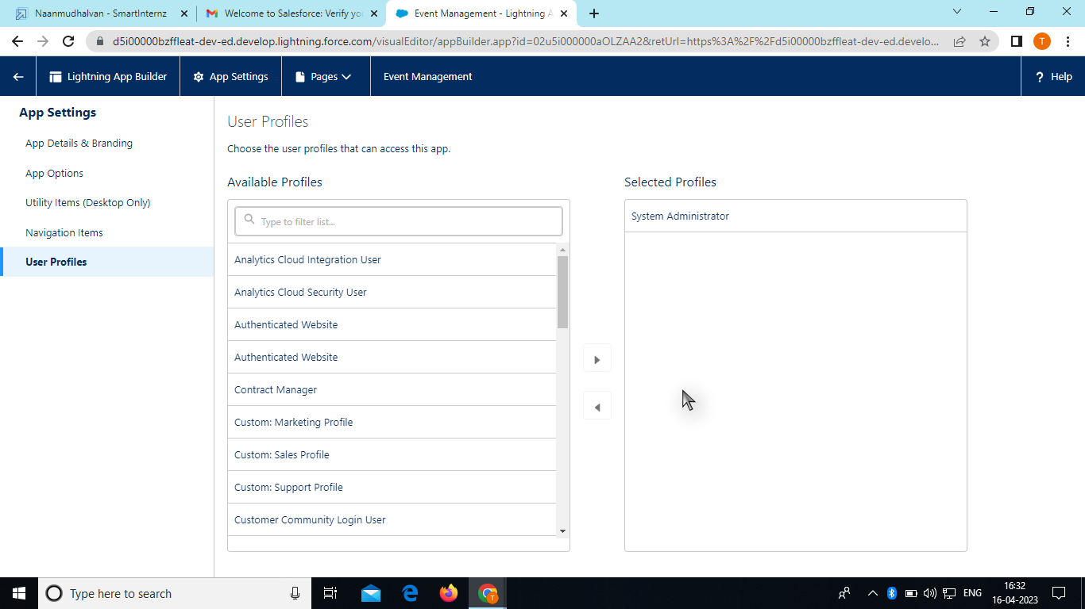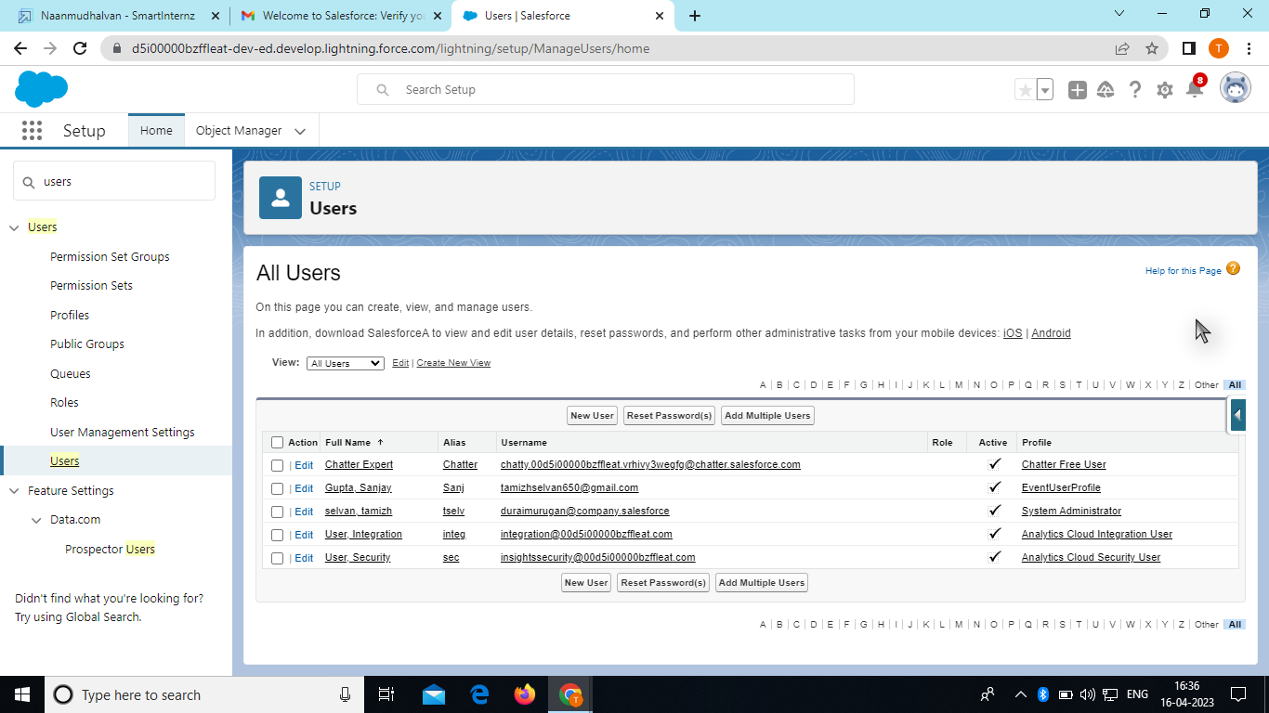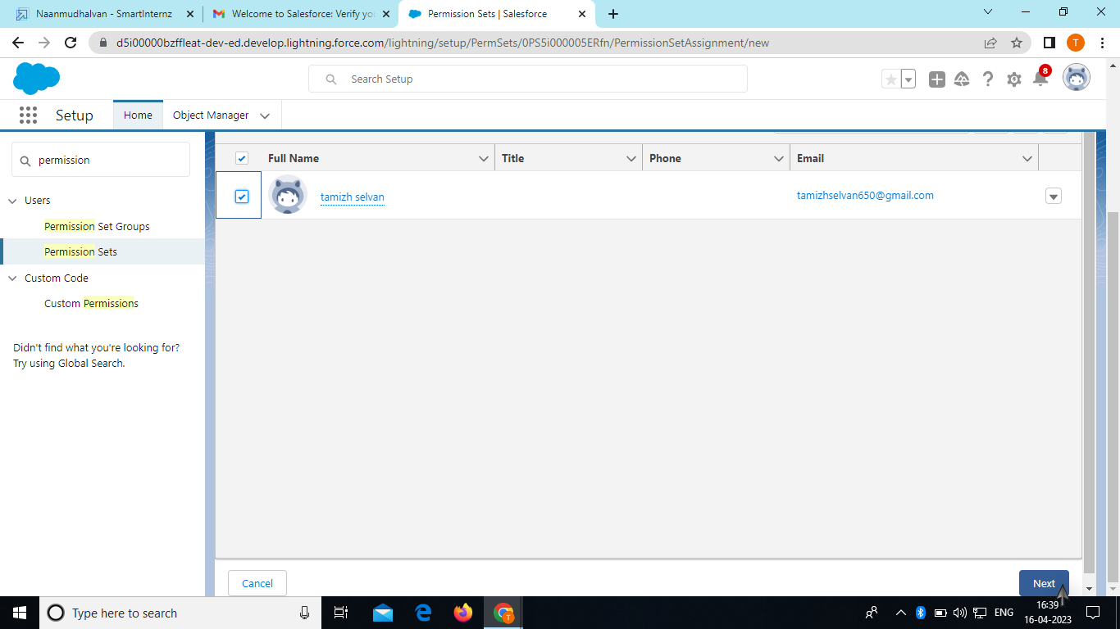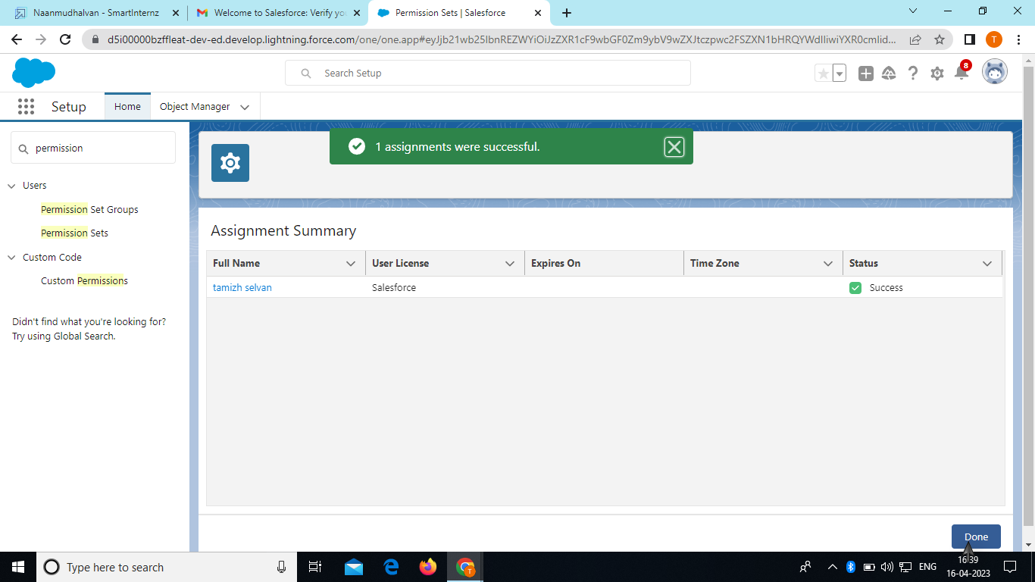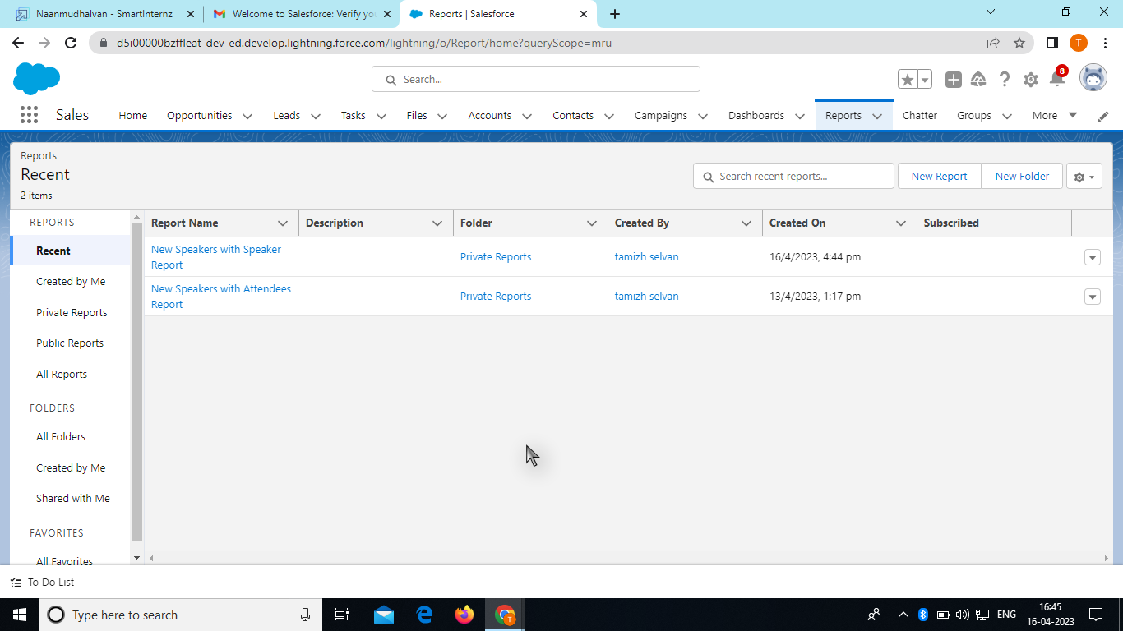

# TRAILHEAD PROFILE PUBLIC URL

Team Leader: <https://trailblazer.me/id/ddharani18>

Team member1: <https://trailblazer.me/id/darumugam12>

Team member2: <https://trailblazer.me/id/bbalaji88>

Team member3: <https://trailblazer.me/id/ddeepika38>

# ADVANTAGES

1. Centralized Data Management: Salesforce offers a robust and scalable cloud-based platform for managing all event-related data in a centralized location. This includes attendee information, event details, registration data, payment processing, and more. This centralized data management allows for easy access, analysis, and reporting, leading to improved event planning and decision-making.
2. Customization and Flexibility: Salesforce provides a highly customizable platform that can be tailored to meet the unique requirements of an event management system. Custom objects, fields, and workflows can be created to capture event-specific data, and custom processes and automation can be built to streamline event registration, payment processing, and attendee management. Salesforce also offers a wide range of pre-built apps and integrations that can be leveraged to extend the functionality of the event management system.
3. CRM Integration: Salesforce is a leading customer relationship management (CRM) platform, which means that event data can be integrated with customer data in Salesforce, providing a holistic view of attendees, prospects, and customers. This allows for better targeting and segmentation of event attendees based on their relationship with the organization, leading to improved engagement and conversion rates.
4. Marketing and Communication: Salesforce offers robust marketing automation tools that can be used to create and execute targeted email campaigns, social media promotions, and other marketing efforts to promote events and engage with attendees. This can help organizations effectively market their events, drive attendance, and build stronger relationships with attendees before, during, and after the event.
5. Reporting and Analytics: Salesforce provides powerful reporting and analytics capabilities that can be used to gain insights into event performance, attendee behavior, and other key metrics. This data can be used to optimize event strategies, measure ROI, and make data-driven decisions to improve future events.

## DISADVANTAGES

Building an event management system using Salesforce has its advantages, as Salesforce is a powerful and widely used customer relationship management (CRM) platform with robust features for managing contacts, opportunities, and workflows. However, there are also some disadvantages to consider when using Salesforce as an event management system. Here are a few potential disadvantages:

1. Limited event-specific functionality: While Salesforce has a wide range of features for managing contacts, opportunities, and sales processes, it may lack specialized functionality for event management, such as attendee registration, event scheduling, ticketing, and seating arrangements. This may require additional customization or integration with third-party applications, which can be time-consuming and costly.
2. Steeper learning curve: Salesforce is a complex platform with a steep learning curve, requiring training and expertise to set up and configure properly. Building an event management system within Salesforce may require a solid understanding of Salesforce's data model, object structure, and customization options, which may be challenging for users who are not already familiar with the platform.
3. Cost: Salesforce is a premium CRM platform that comes with a cost, including licensing fees, implementation costs, and ongoing maintenance expenses. Building a custom event management system within Salesforce may require additional customization, which can increase the overall cost of the solution.
4. Limited scalability: Salesforce has limits on the number of custom objects, records, and storage available based on the edition and licensing model being used. Depending on the size and complexity of your events, you may encounter limitations on data storage or the number of events or attendees you can manage within Salesforce.
5. Dependency on Salesforce updates: Salesforce regularly releases updates and new features, which may impact customizations and integrations. When building an event management system within Salesforce, you may need to consider the potential impact of Salesforce updates and plan for necessary changes or adjustments to your custom solution.

# APPLICATION

1. Salesforce Objects: Create custom Salesforce objects to represent different entities in your event management system, such as Events, Attendees, Speakers, Sponsors, and Registrations. Define the fields, relationships, and validation rules for each object based on your requirements.
2. Automation: Use Salesforce automation tools like Process Builder or Workflow Rules to automate key tasks in your event management system. For example, you can create workflows to send automated confirmation emails to registrants, update event status based on registration counts, or trigger notifications to speakers and sponsors.
3. Customization: Customize the Salesforce user interface to provide a user-friendly experience for event planners, registrants, and other stakeholders. You can create custom record types, page layouts, and Lightning components to tailor the system to your specific needs. You can also use Salesforce's built-in features for managing events, such as Campaigns and Campaign Members, to track and manage event-related data.
4. Integration: Integrate your event management system with other external systems and tools using Salesforce integrations. For example, you can integrate with email marketing platforms like Mailchimp to send event invitations and track RSVPs, or with payment gateways like PayPal or Stripe to process event registration payments

# CONCLUSION

1. Integration: Integrate your event management system with other Salesforce features like Contacts, Accounts, and Opportunities to capture leads, track revenue, and manage customer relationships. You can also integrate with external systems like payment gateways, event registration platforms, or marketing automation tools using Salesforce's APIs or third-party integration tools like Zapier or Jitterbit.
2. Mobile Access: Utilize Salesforce's mobile app or build custom mobile apps using Salesforce Mobile SDK to allow event organizers, speakers, and attendees to access event information, register for events, check-in attendees, and receive event updates on the go.
3. Security: Implement appropriate security measures such as user profiles, permission sets, field-level security, and sharing rules to ensure that event data is secure and only accessible to authorized users.
4. User Training and Support: Provide training and support to your event organizers, speakers, and attendees on how to use the event management system effectively. Create documentation, user guides, and training materials, and provide ongoing support through Salesforce's Community Cloud, Chatter, or a dedicated support portal.

By following these steps, you can build a comprehensive event management system using Salesforce that meets the needs of your organization and helps you efficiently plan, organize, and manage successful events.

Top of Form

# FUTURE SCOPE

Future Scope Ideas:

1. Mobile App Integration: Develop a mobile app for your event management system to allow attendees to register for events, view event details, and receive event updates. You can integrate the mobile app with Salesforce using Salesforce Mobile SDK or other mobile app development frameworks.
2. Social Media Integration: Integrate your event management system with social media platforms, such as Facebook, Twitter, and LinkedIn, to promote events, generate buzz, and drive registrations. You can use Salesforce Social Studio or third-party social media management tools to manage social media campaigns and track their impact on event registrations.
3. AI-powered Insights: Utilize Salesforce Einstein, Salesforce's built-in AI capabilities, to gain insights from event data. For example, you can use Einstein Analytics to analyze event registration trends, predict attendance, and identify potential upsell or cross-sell opportunities.
4. Virtual Events: With the rise of virtual events, you can expand your event management system to support virtual event registration, attendee engagement, and analytics. You can integrate with virtual event platforms, such as Zoom or Microsoft Teams, to enable virtual event experiences within your event management system.
5. Gamification: Incorporate gamification elements into your event management system to drive attendee engagement and increase event participation. For example, you can create leaderboards, offer badges or rewards, and implement gamified challenges to encourage attendees to interact with your events and share them on social media.
6. Personalization: Utilize